

**A project Report on**

AMAZON WEBSITE TESTING USING AUTOMATION TOOL SELENIUM WEBDRIVER WITH JAVA

**By**

**ABARNA R**

**Batch-SOC-TESTING (2021-5533)**

**Under the Guidance of,**

**AMRUTA DEORE (Technical Trainer)**

***EduBridge India Pvt.Ltd.***

**Introduction:**

This Project aims to do overall testing like functional testing, GUI testing on Amazon website to check quality of application using selenium web driver. It helps to improve quality of website and saves time for manually doing this testing.

Amazon.com is a **vast Internet-based enterprise** that sells books, music, movies, housewares, electronics, toys, and many other goods, either directly or as the middleman between other retailers and Amazon. com's millions of customers.

In this project our main focus is to test the web elements using the locators such as ID, class name, name, and Paths etc.

**Software Requirements:**

*Operating System: Windows 10*

*Browser: Latest version of Google Chrome*

*Platform: Eclipse IDE*

*Automation Tool and Language: Selenium WebDriver, Java*

*Files: JDK, Selenium Jar files, Common IO file*

**TC01: Launch the browser and Amazon website**

**Selenium WebDriver Test Script:**

System.*setProperty*("webdriver.chrome.driver","C:\\seleniumwebdriver\\chromedriver\\chromedriver_win32//chromedriver.exe");

WebDriver driver=**new** ChromeDriver();

driver.get("https://www.amazon.in/");

driver.manage().window().maximize();

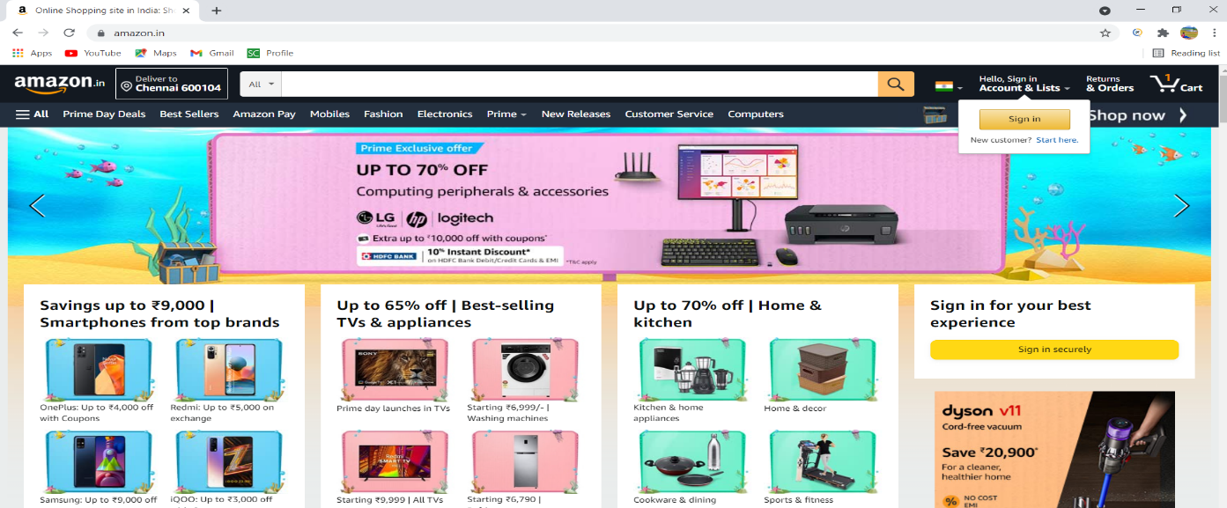

**TC02: To verify and display the URL of Current page of browser.**

**Selenium WebDriver Test Script:**

driver.getCurrentUrl();

System.***out***.println("Current URL IS:" + driver.getCurrentUrl());

**TC03: To verify the functionality of scroll up and scroll down.**

**Selenium WebDriver Test Script:**

JavascriptExecutor js=(JavascriptExecutor)driver;

js.executeScript("window.scrollBy(0,5000)"); //for scrolling down

System.***out***.println("scrolled down");

Thread.*sleep*(2000);

JavascriptExecutor js1=(JavascriptExecutor)driver;

js1.executeScript("window.scrollBy(0,-3000)"); //for scrolling up

System.***out***.println("scrolled up");

Thread.*sleep*(2000);

**TC04: To verify the functionality of navigating back and front**.

**Selenium WebDriver Test Script:**

driver.navigate().back(); //navigating back

System.***out***.println("navigated back");

Thread.*sleep*(2000);

driver.navigate().forward();

System.***out***.println("navigated forward"); //navigating front

Thread.*sleep*(2000);

**TC05: To verify whether the length of the title is obtained**.

**Selenium WebDriver Test Script:**

String title = driver.getTitle(); // Storing Title name in the String variable

**int** titleLength = driver.getTitle().length(); // Storing Title length in the Int variable

System.***out***.println("Title of the page is : " + title);

System.***out***.println("Length of the title is : "+ titleLength);

Thread.*sleep*(2000);

**TC06: To verify the title.**

**Selenium WebDriver Test Script:**

String expectedtitle="Online Shopping site in India: Shop Online for Mobiles, Books, Watches, Shoes and More - Amazon.in";

String actualtitle="";

actualtitle=driver.getTitle();

System.***out***.println(actualtitle);

**if**(actualtitle.contentEquals(expectedtitle))

{

System.***out***.println("Test passed");

}

**else**

{

System.***out***.println("Test failed");

}

System.***out***.println("title is checked");

Thread.*sleep*(2000);

**TC07**: **To verify whether Image is clicked**.

**Selenium WebDriver Test Script:**

driver.findElement(By.*id*("nav-logo-sprites")).click();

System.***out***.println("image is clicked");

**TC08: To verify the functionality of language setting .**

**Selenium WebDriver Test Script:**

WebElementelement=driver.findElement(By.*xpath*("//header/div[@id='navbar']/div[@id='nav-belt']/div[3]/div[1]/a[1]/span[1]"));

Actions builder=**new** Actions(driver);

builder.moveToElement(element).build().perform();

element.click();

Thread.*sleep*(2000);

//RADIO BUTTON

WebElement radio= driver.findElement(By.*xpath*("//body/div[@id='a-page']/div[@id='customer-preferences']/div[1]/div[1]/form[1]/div[1]/div[1]/div[3]/div[1]/label[1]/i[1]"));

radio.click();

System.***out***.println(radio.isSelected());

Thread.*sleep*(2000); driver.findElement(By.*xpath*("//a[@id='icp-btn-close-announce']")).click();

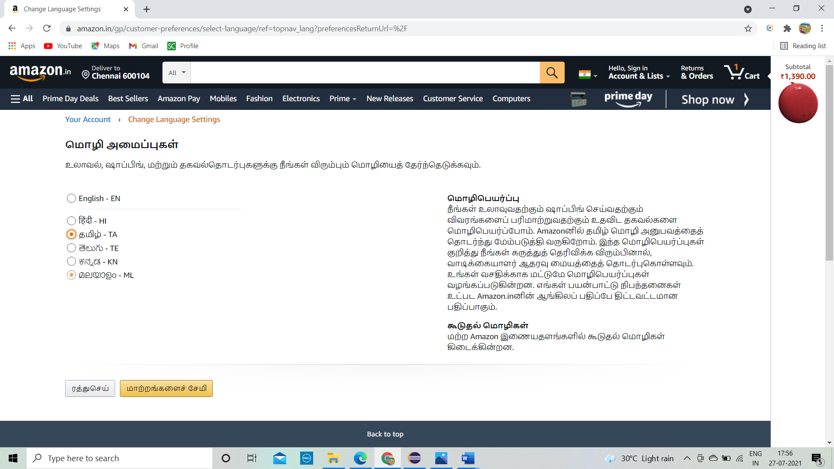

**TC09: To verify the functionality of categories from drop down.**

**Selenium WebDriver Test Script:**

Select drplist =**new** Select(driver.findElement(By.*id*("searchDropdownBox")));

drplist.selectByValue("search-alias=electronics"); //from dropdown electronics is selected

Thread.*sleep*(2000);

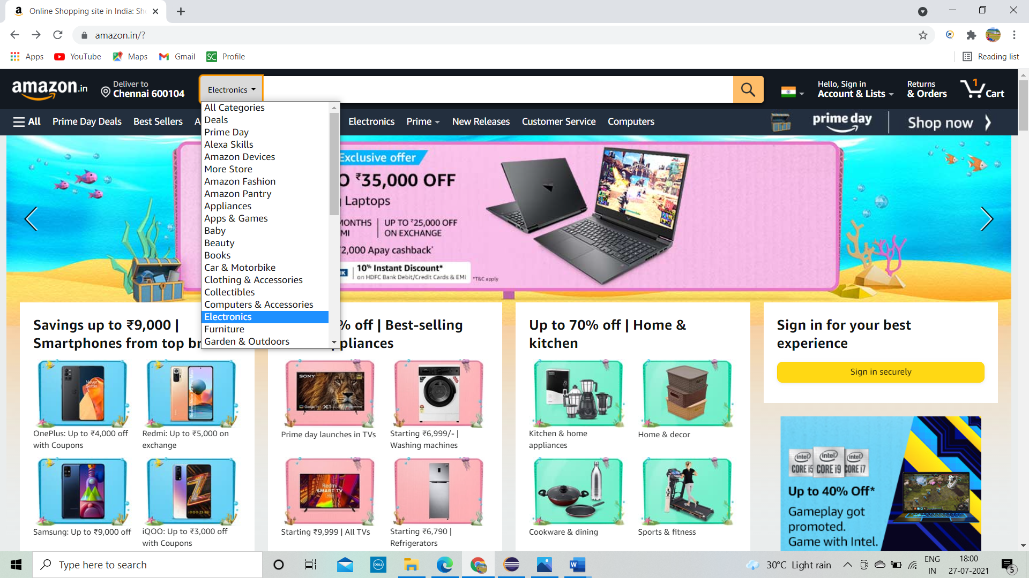

**TC10: To verify the functionality of Search Bar.**

**Selenium WebDriver Test Script:**

driver.findElement(By.*name*("field-keywords")).sendKeys("boat stone 190f 5w bluetooth speaker");

driver.findElement(By.*id*("nav-search-submit-button")).click();

Thread.*sleep*(2000);

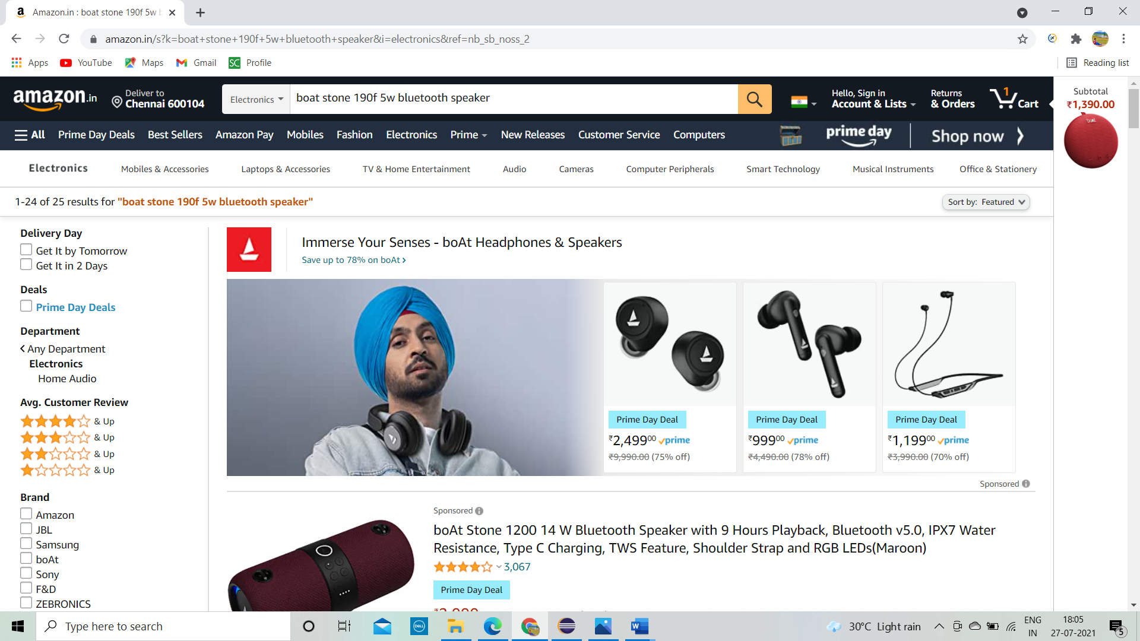

**TC11: To verify the functionality of brand and pay on delivery check boxes**.

**Selenium WebDriver Test Script:**

driver.findElement(By.*xpath*("//*[@id=\"p_89/boAt\"]/span/a/div/label/i")).click();

driver.findElement(By.*xpath*(" //*[@id=\"p_n_is_cod_eligible/4931671031\"]/span/a/div/label/i")).click();

Thread.*sleep*(2000);

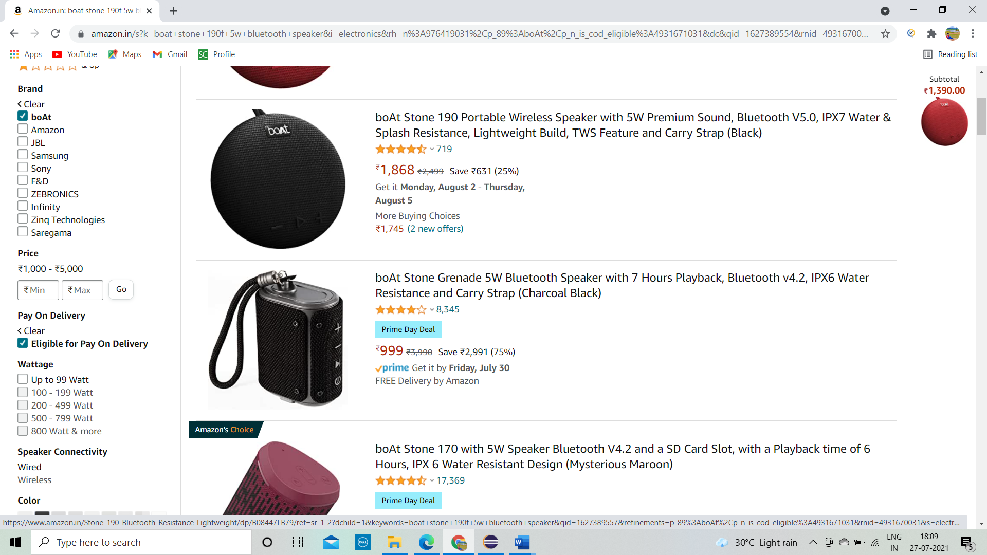

**TC12: To verify the functionality of fetching the first product.**

**Selenium WebDriver Test Script:**

driver.findElement(By.*className*("s-image")).click();

**TC13: To verify the functionality of switching into child windows.**

**Selenium WebDriver Test Script:**

Set<String> s1= driver.getWindowHandles();

Iterator<String>i1=s1.iterator();

**while**(i1.hasNext())

{

String childwindow=i1.next();

**if**(! mainwindow.equalsIgnoreCase(childwindow))

{

driver.switchTo().window(childwindow);

}

}

**TC14: To verify the functionality of selecting Quantity.**

**Selenium WebDriver Test Script:**

String mainwindow=driver.getWindowHandle();

Set<String> s1= driver.getWindowHandles();

Iterator<String>i1=s1.iterator();

**while**(i1.hasNext())

{

String childwindow=i1.next();

**if**(! mainwindow.equalsIgnoreCase(childwindow))

{

driver.switchTo().window(childwindow);

Select drplist1=**new** Select(driver.findElement(By.*id*("quantity")));

drplist1.selectByValue("2");

Thread.*sleep*(2000);

}

**TC15: To verify the functionality of fetching Warranty details.**

**Selenium WebDriver Test Script:**

String mainwindow=driver.getWindowHandle();

Set<String> s1= driver.getWindowHandles();

Iterator<String>i1=s1.iterator();

**while**(i1.hasNext())

{

String childwindow=i1.next();

**if**(! mainwindow.equalsIgnoreCase(childwindow))

{

driver.switchTo().window(childwindow);

// FETCHING WARRANTY DETAILS

WebElement=warranty=driver.findElement(By.*xpath*("//a[contains(text(),'1 Year Warranty')]"));

warranty.click();

System.***out***.println(warranty.getText()) ;

**TC16: To verify the functionality of Add to Cart.**

**Selenium WebDriver Test Script:**

String mainwindow=driver.getWindowHandle();

Set<String> s1= driver.getWindowHandles();

Iterator<String>i1=s1.iterator();

**while**(i1.hasNext())

{

String childwindow=i1.next();

**if**(! mainwindow.equalsIgnoreCase(childwindow))

{

driver.switchTo().window(childwindow);

//ADDING ITEMS TO CART driver.findElement(By.*xpath*("//input[@id='add-to-cart-button']")).click();

Thread.*sleep*(2000);

}

}

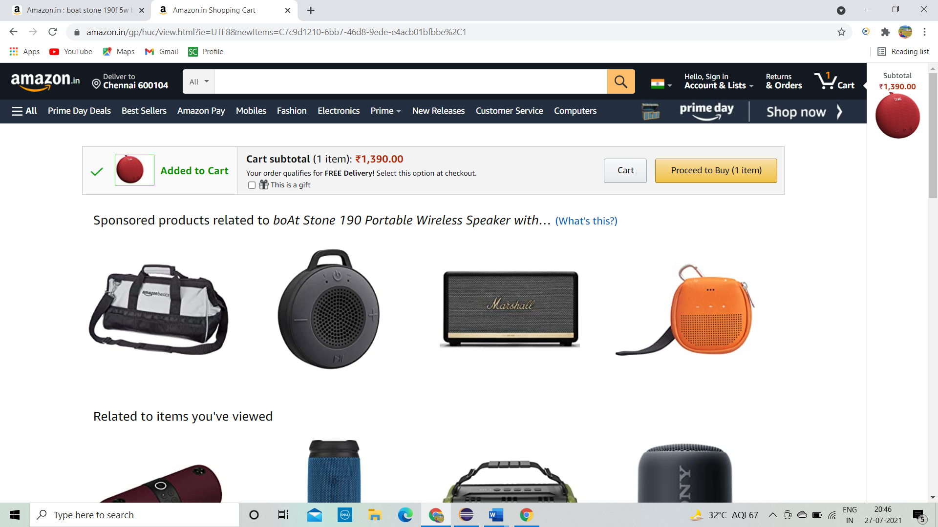

**TC17: To verify the functionality of cart button.**

**Selenium WebDriver Test Script:**

driver.findElement(By.*linkText*("Cart")).click();

Thread.*sleep*(2000);

**TC18: To verify the functionality of refresh.**

**Selenium WebDriver Test Script:**

driver.navigate().refresh();

Thread.*sleep*(2000);

**TC19: To verify that browser is able to send the Download link.**

**Selenium WebDriver Test Script:**

driver.findElement(By.*xpath*("//header/div[@id='navbar']/div[@id='nav-main']/div[3]/div[1]/div[1]/a[1]")).click();

driver.findElement(By.*xpath*("//input[@id='mgt-email-sms-input']")).sendKeys("flipkartdemo99@gmail.com");

driver.findElement(By.*className*("a-button-input")).click();

**TC20: To verify that browser is able to close the current page.**

**Selenium WebDriver Test Script:**

driver.close();

**TC21: To verify that browser is able to quit**.

**Selenium WebDriver Test Script:**

driver.quit(); //all the pages are closed